CE-365 Compiler Construction

Mini Project

Project Definition:
While Loop Syntax Analyzer

Programming Language:
C++

Prepared by:
Shreyansh pipaliya (23ce116)
Aayush tilva (23ce137)
Sunny radadiya(23ce122)

While Loop:
while (condition)
{
// statements
}

CFG:
S → WHILE ( E ) { S }
S → S S
S → id = E ;
E → E + T
E → T
T → id | num
Non-terminals: S, E, T
Terminals: while, (, ), {, }, id, num, +, =, ;

Output:
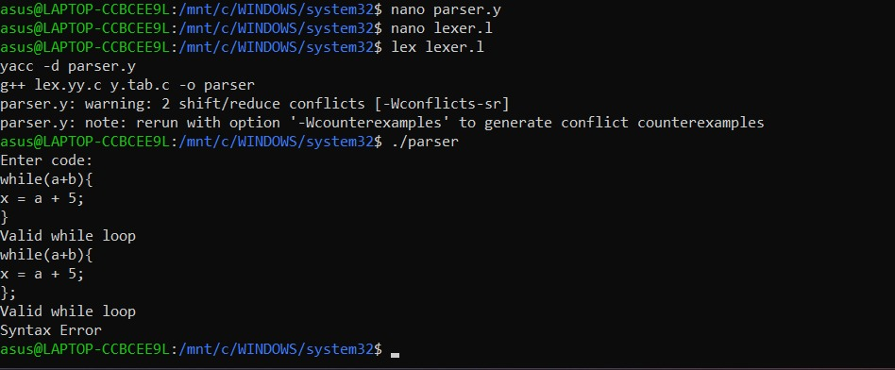

To run file:
Open WSL where lexer.l and parser.y are located
lex lexer.l
yacc -d parser.y
g++ lex.yy.c y.tab.c -o parser
./parser
Then enter test cases
Press Ctrl+D to end input

Test Cases:
✅ Valid Input:
while(x){
a = b + 5;
}
❌ Invalid Input:
while x {
a = b + 5
}

